Google Play Assets:

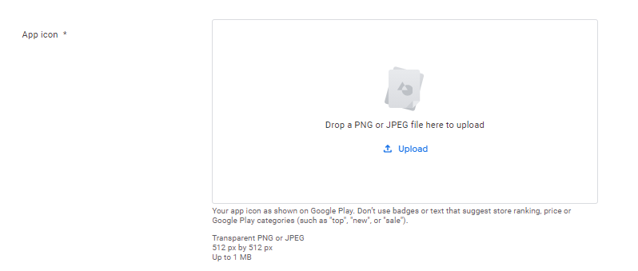Main Icon:

Wide image: (cover photo)

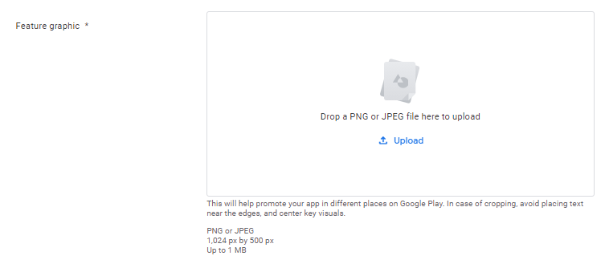

Screenshots:

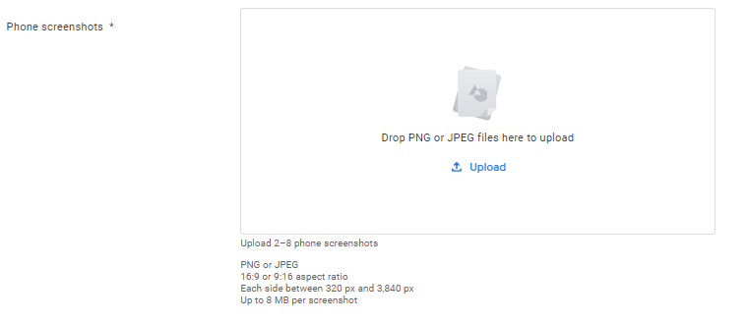

* Experience exclusive short-term rental accommodation designed for comfort.
* Distinguished high-end residential units located in the most popular locations. A complete set of advanced facilities. Comprehensive range of customer service solutions. Bubat specializes in the units we manage that exceed expectations, providing a short stay for unforgettable memories.